Project Development Phase
Model Performance Test

Date | 03 October 2026
Team ID | SWTID-2026-8647
Project Name | Implement Client Script & UI Policy (Incident)
Maximum Marks

Model Performance Testing:
Project team shall fill the following information in model performance testing template.
S.No. | Parameter | Values | Screenshot
1. | Configuration Summary | ServiceNow Incident form configuration using UI Policy Actions and Client Scripts.  UI Policy Actions are used to control field behavior such as mandatory and read-only settings. Client Scripts are configured to support dynamic Incident form behavior and validation.  Project: Implement Client Script & UI Policy (Incident) | 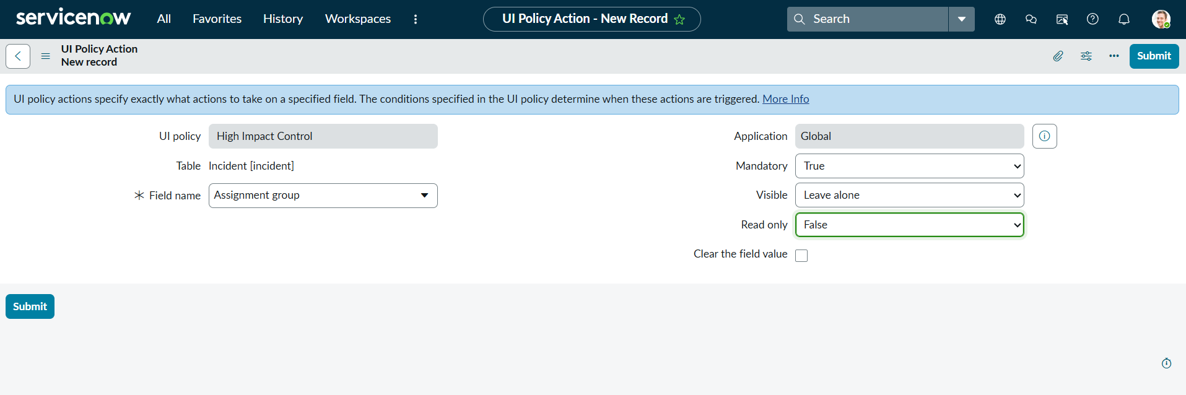  Figure 1: Assignment Group UI Policy Action  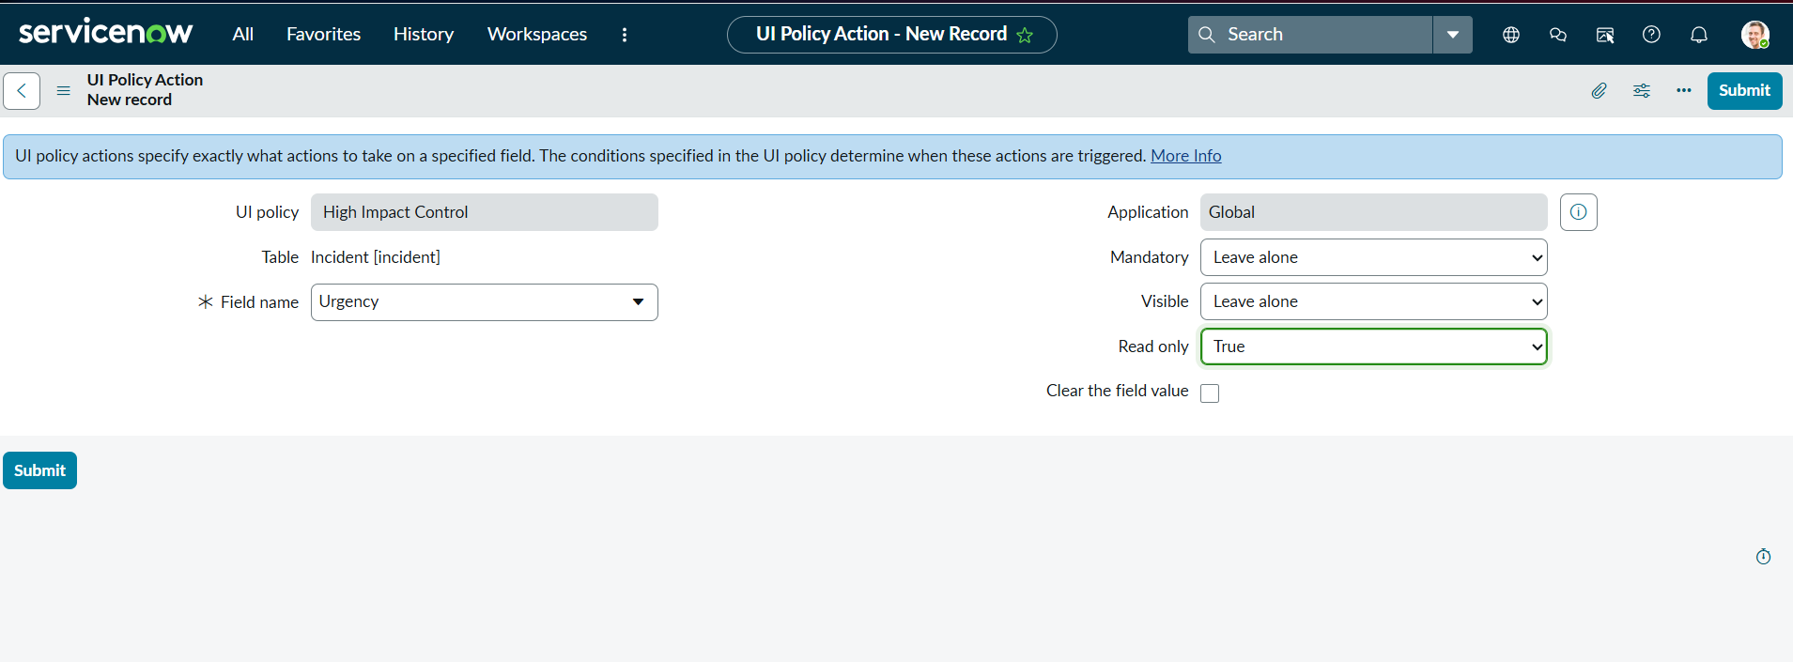  Figure 2: Urgency UI Policy Action
2. | Configuration Verification | UI Policy Actions configured for Assignment group and Urgency on the Incident form.  Assignment group: Mandatory = True.  Urgency: Read-only = True.  Execution/testing result: To be verified during implementation. | 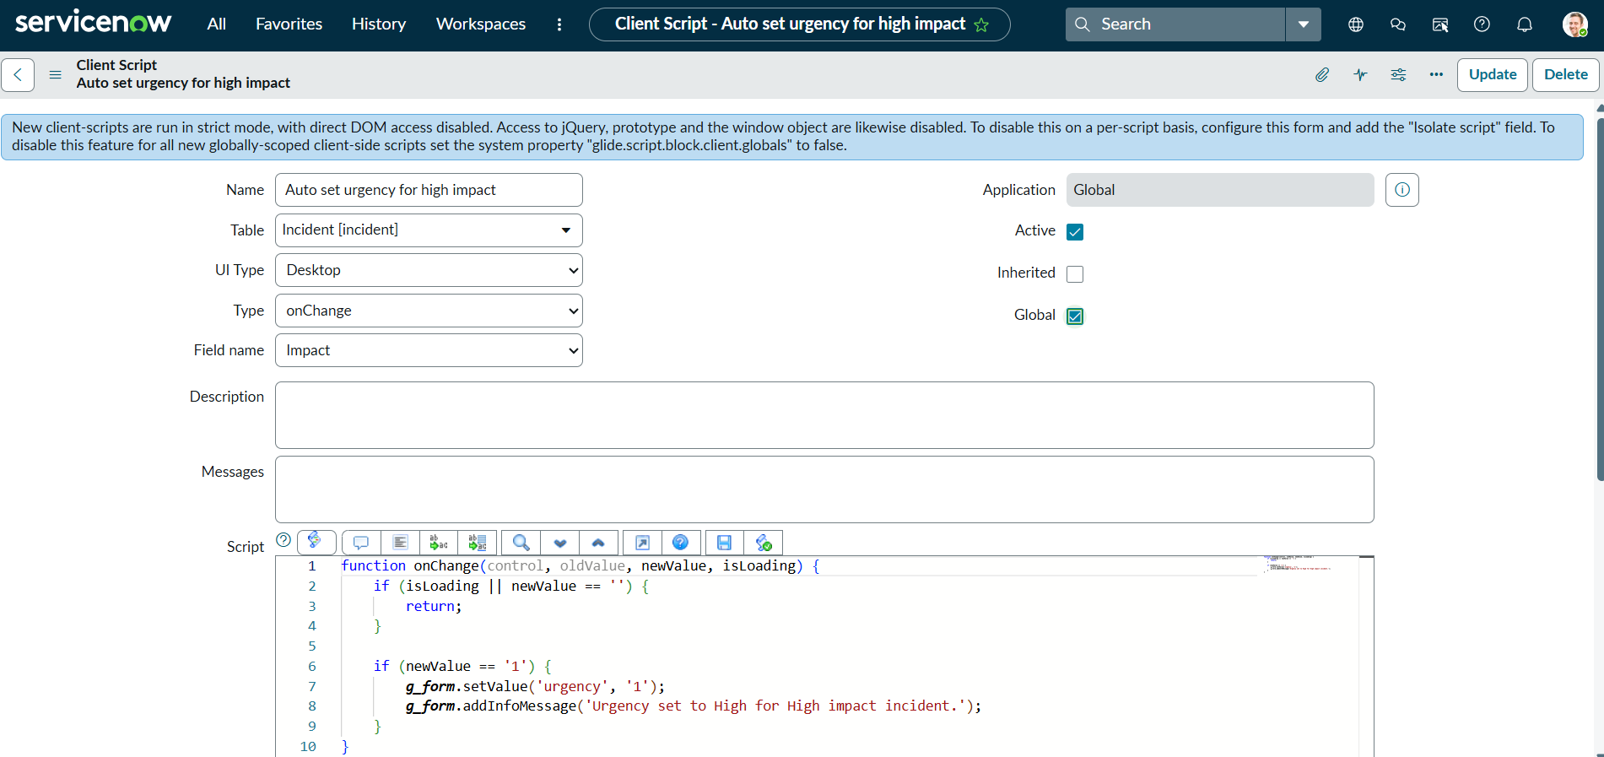  Figure 3: Auto Set Urgency Client Script
3. | Client Script / Functional Verification | Client Script configurations documented for:  • Auto-setting urgency for high-impact incidents.  • Preventing save when Assigned To is missing.  • Preventing State changes through list editing.  Runtime behavior: To be verified during implementation. | 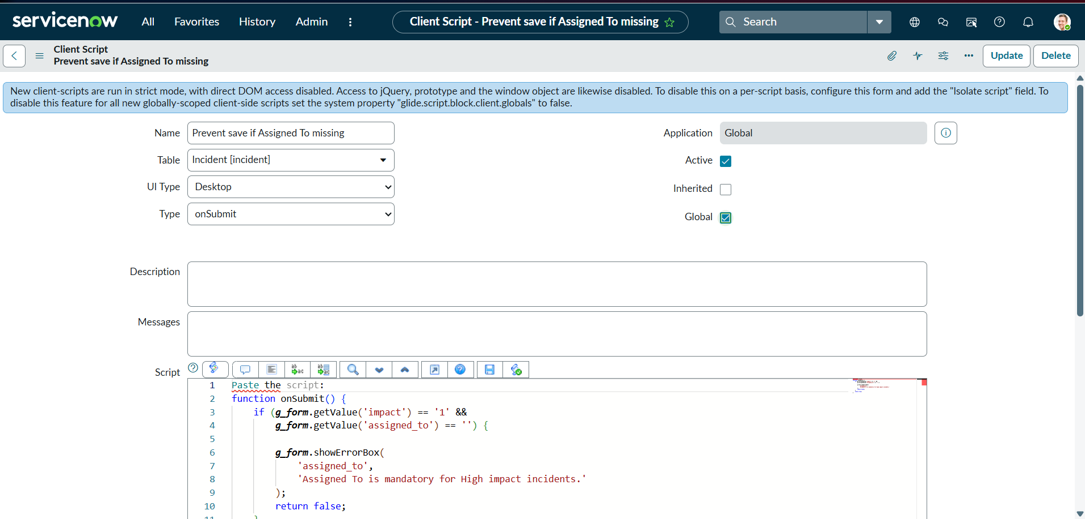  Figure 4: Prevent Save Client Script  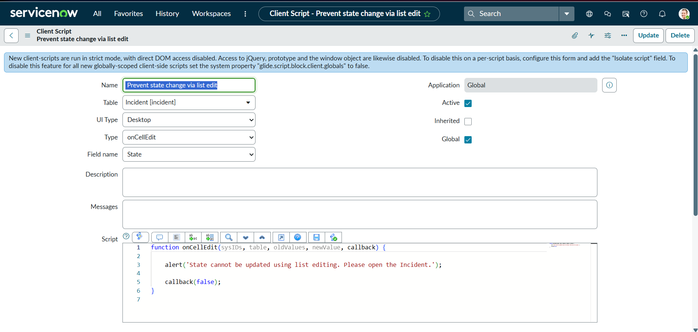  Figure 5: Prevent State Change via List Edit

